**2403a51353 Batch - 14**

**Task Description #1**

* Use Google Gemini in Colab to write a Python function that reads a list of numbers and calculates the mean, minimum, and maximum values.

|  |  |  |  |  |
| --- | --- | --- | --- | --- |
| **Google Colab** Code:  **Screenshot 2025-08-06 120225.png** | | | **Cursor Code:**  Screenshot 2025-08-06 120801.png | |
| **Screenshot 2025-08-06 120310.png** | | | **Screenshot 2025-08-06 120846.png** | | |
|  |  | |

Task Description #2

* Compare Gemini and Copilot outputs for a Python function that checks whether a number is an Armstrong number. Document the steps, prompts, and outputs.

|  |  |
| --- | --- |
| **Google Colab** Code:  Screenshot 2025-08-11 065103 | **Cursor Code:**  Screenshot 2025-08-11 091741Screenshot 2025-08-11 091819 |
|  |  |

Task Description #3

Ask Gemini to explain a Python function (e.g., is_prime(n) or is_palindrome(s)) line by line

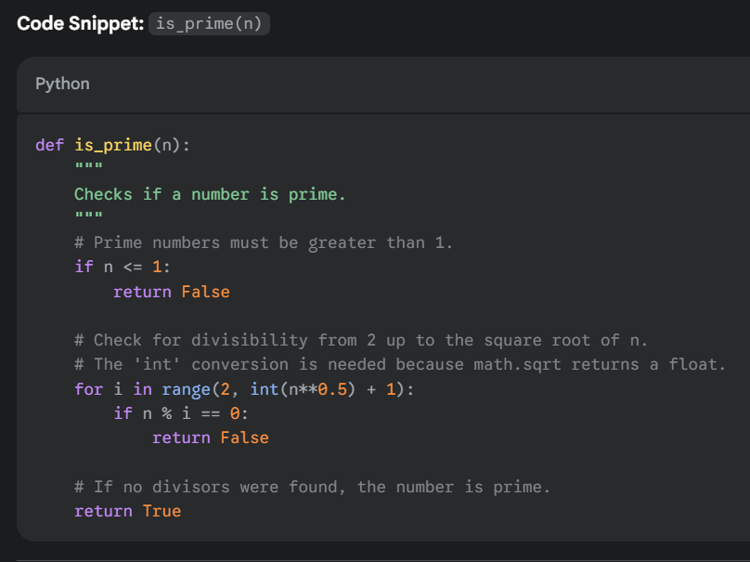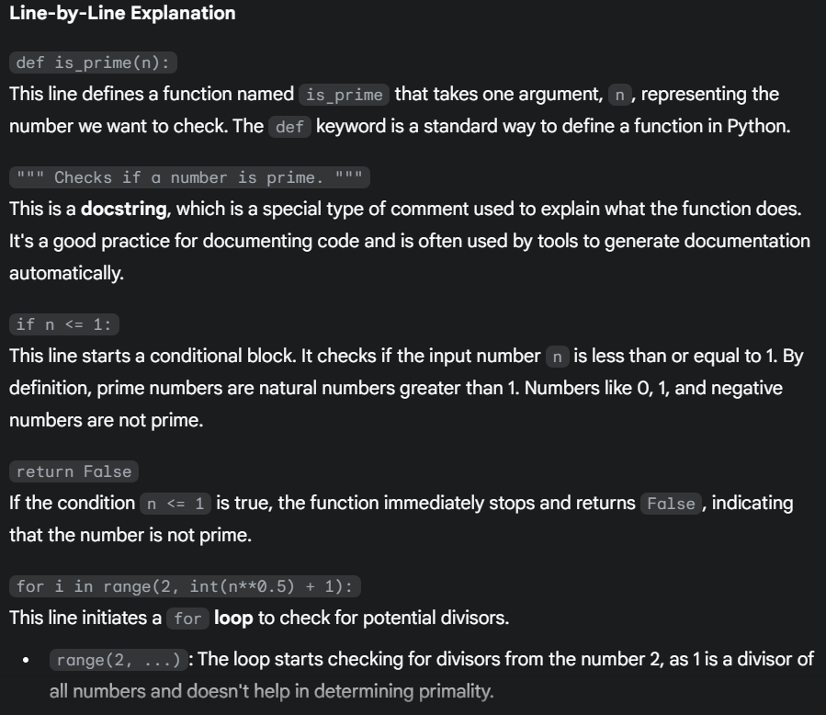

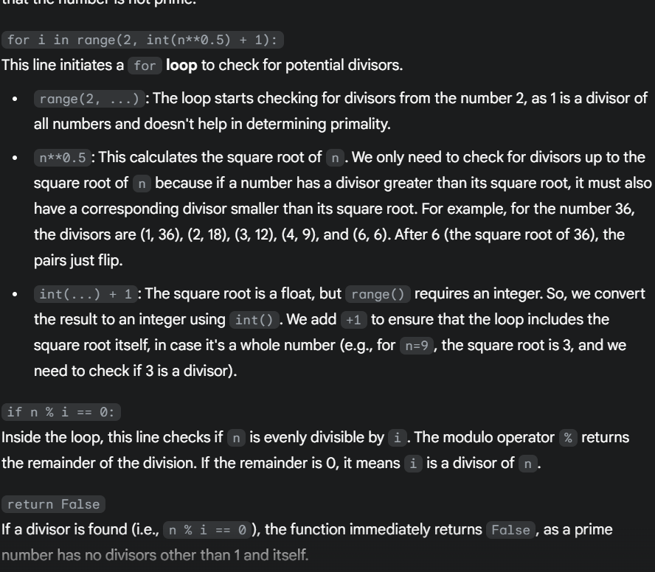

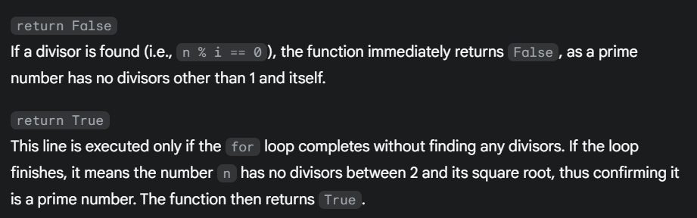

Task Description #4

* Install and configure Cursor AI. Use it to generate a Python function (e.g., sum of the first N natural numbers) and test its output.
* Optionally, compare Cursor AI’s generated code with Gemini’s output.

|  |  |
| --- | --- |
| Gemini Output: | Cursor Output: |

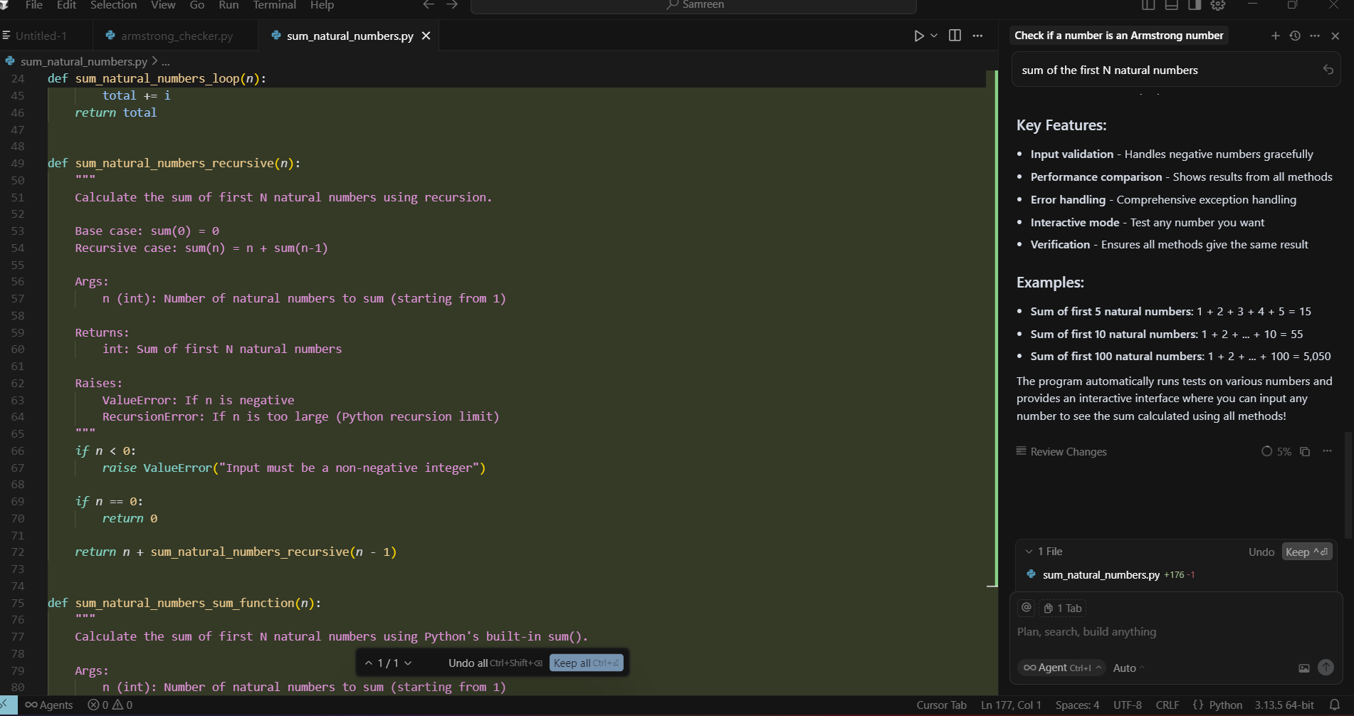

Task Description #5

* Students need to write a Python program to calculate the sum of odd numbers and even numbers in a given tuple.
* Refactor the code to improve logic and readability.

